Academic Year: 2025-26 | Year: Second Year | Semester: II
PRN No.: 1012411011 | Name: Riddhee Kulkarni
Subject: Python Programming
Assignment No.: 19
Date: 16/03/2026

Lab Assignment: 19
Aim:
To write a Python program to demonstrate the use of search(), findall(), and sub() functions from the re (regular expression) module.

Objective:
- To understand the concept of Regular Expressions in Python.
- To demonstrate pattern searching using search().
- To extract multiple matches using findall().
- To replace matched patterns using sub().

Theory:
Regular Expressions (RegEx) are sequences of characters that define a search pattern. In Python, the re module provides functions for working with regular expressions.
- search()
- The re.search() function scans the entire string and returns the first match of the pattern.
- If the pattern is found, it returns a match object; otherwise, it returns None.
- findall()
- The re.findall() function returns a list containing all matches of the pattern in the string.
- sub()
- The re.sub() function replaces all occurrences of the pattern with a specified replacement string.

For example, the pattern \d+ matches one or more digits in a string.

Algorithm:
- Start the program.
- Import the re module.
- Accept a string from the user.
- Accept a pattern to search.
- Use re.search() to check whether the pattern exists in the string.
- Display whether the pattern is found or not.
- Use re.findall() to find all occurrences of the pattern.
- Display the list of matches.
- Accept replacement text from the user.
- Use re.sub() to replace the pattern with the replacement text.
- Display the modified string.
- End the program.

Pseudo Code:
START
IMPORT re module

INPUT text
INPUT pattern

CALL re.search(pattern, text)
IF result exists
PRINT "Pattern found"
ELSE
PRINT "Pattern not found"

CALL re.findall(pattern, text)
PRINT list of matches

INPUT replacement text

CALL re.sub(pattern, replacement, text)
PRINT modified string

END

Code:
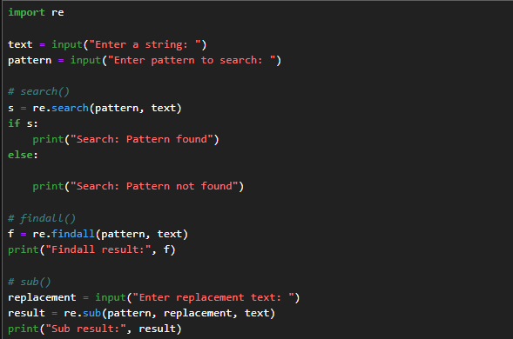

Output:
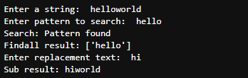

Conclusion:
Thus, the Python program was successfully implemented to demonstrate the use of search(), findall(), and sub() functions from the re module for pattern matching, extraction, and replacement in strings.

